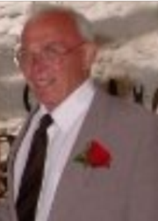

Henry Forster

17.09.1933 - 16.10.2013

Tuesday 29th October 2013

Order of Service

Opening music: I have had the time of my life (Dirty Dancing)

Introduction and Opening Prayers

All: Merciful Father, hear our prayers and comfort us; renew our trust in your Son, whom you raised from the dead; strengthen our faith that all who have died in the love of Christ will share in his resurrection; who lives and reigns with you, in the unity of the Holy Spirit, one God, now and for ever. Amen

The Scriptural Reading: John 14. 1-6

The Eulogy/Tribute

A Letter from Nicola to her Dad read by Tracey Morris

A Time for Refection Ave Maria (Celine Dion)

The Prayers:

Each section concludes:
Lord, in your mercy
All: hear our prayer.

After the final section:
All: God of mercy, entrusting into your hands all that you have made and rejoicing in our communion with all your faithful people, we make our prayers through Jesus Christ our Saviour. Amen.
The Lord’s Prayer

Our Father, who art in heaven, hallowed be thy name; thy kingdom come; thy will be done; on earth as it is in heaven. Give us this day our daily bread. And forgive us our trespasses, as we forgive those who trespass against us. And lead us not into temptation; but deliver us from evil. For thine is the kingdom, the power and the glory, for ever and ever. Amen.

Commendation and Farewell, and Committal

Closing Prayers and Blessing

All: Heavenly Father, in your Son Jesus Christ you have given us a true faith and a sure hope. Strengthen this faith and hope in us all our days, that we may live as those who believe in the communion of saints, the forgiveness of sins and the resurrection to eternal life; through Jesus Christ our Lord. Amen.

Closing music I did it my way Frank Sinatra

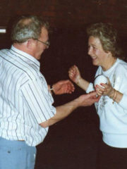

God looked around his garden
And found an empty place,
He then looked down upon the earth
And saw your tired face.
He put his arms around you
And lifted you to rest.
God's garden must be beautiful
He always takes the best.
He knew that you were suffering
He knew you were in pain.
He knew that you would never
Get well on earth again.
He saw the road was getting rough
And the hills were hard to climb.
So he closed your weary eyelids
And whispered, 'Peace be Thine'.
It broke our hearts to lose you
But you didn't go alone,
For part of us went with you
The day God called you home.

